Aged Debt Process

**Step 1 – Generating the Aged Debt file – This report is run every Monday Morning**

Log onto SAS VA using network ID

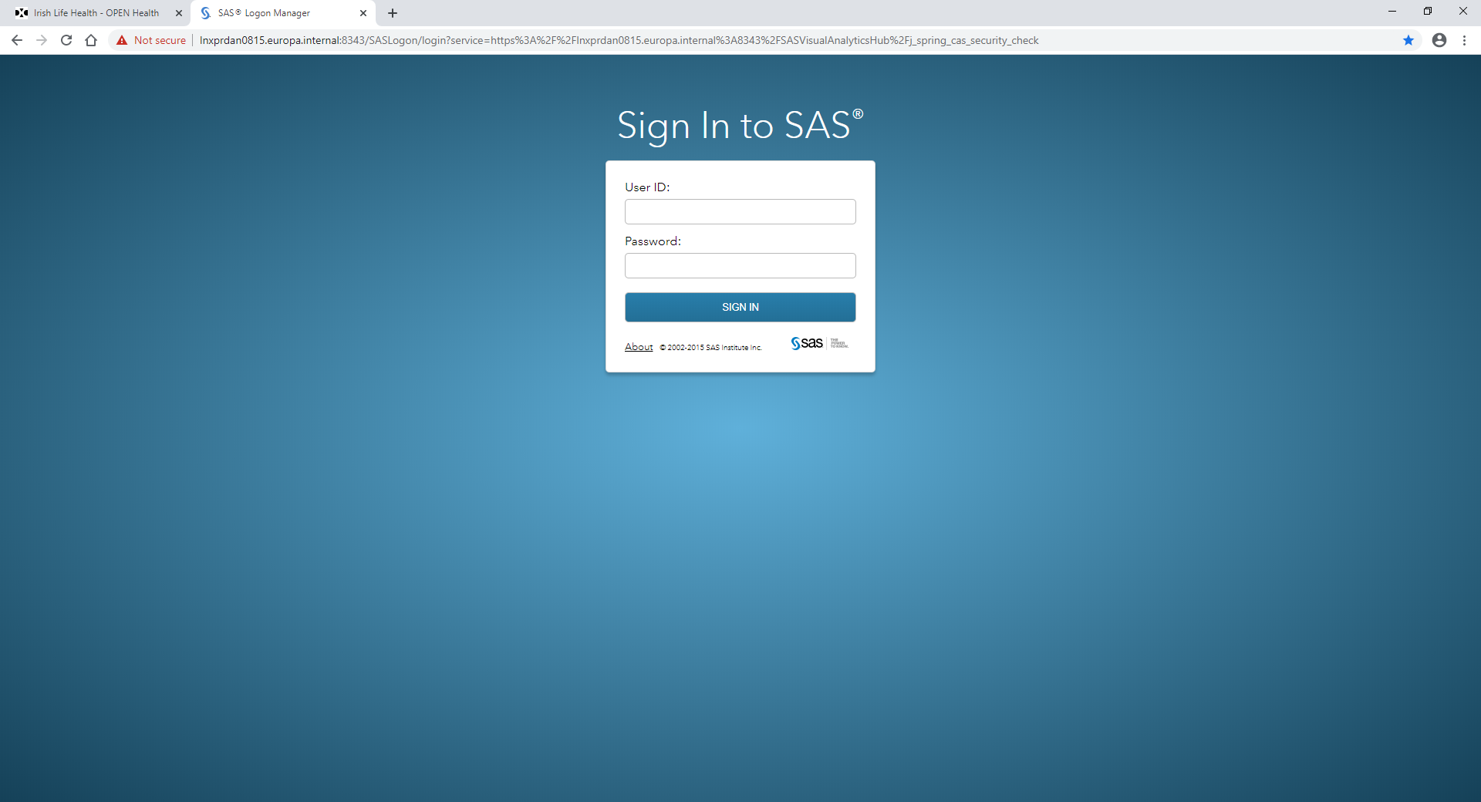

2) Find and Run report called PC18 Aged Debtors Group still to pay and go to the tab named Aged Group Amounts by group

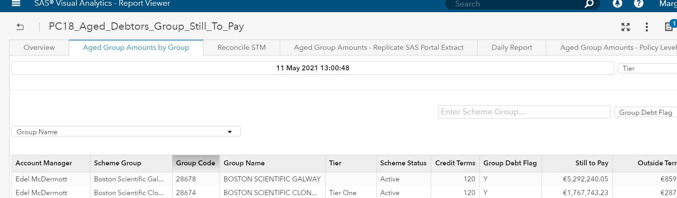

3) Export to excel and save into the below folder

PREMIUM COLLECTIONS\REPORTS - PREMIUM COLLECTIONS\Aged Debtor\2021

**Step 2**

PREMIUM COLLECTIONS\REPORTS - PREMIUM COLLECTIONS\Aged Debtor

1. Open Tier One Schemes – GWP+ 1m
2. In 2021 folder, open this week aged debt file
3. Aged debt file (data tab) – clear contents in Column E (Tier) and complete a vlook from the open tier one scheme spreadsheet.
4. Vlook up below

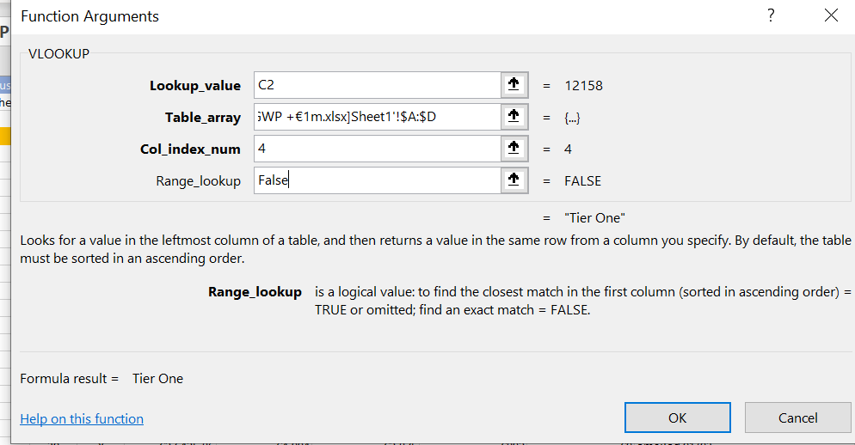

1. Filter out the Tier 1 and change all N/A to non Tiers

**Step 3**

* Open the previous weeks deb file and complete a vlookup from column N #cases into the current weeks file. This will carry over all comments from the previous week into the current week.
* Filter columns 30,60 & 90 days outside terms columns to zero
* Review the outside terms column
* Automatic reminder email 5 days prior to the payment due date to be sent – (Can the invoice be attached to the reminder email or will the email just prompt the SA to look at the portal?) – If invoice not sent with email, can the amount due be listed in the mail and a line referencing the portal for full breakdown.

**Step 4**

A new step to remove manual part to the review.

In SAS run the below report

* Report name: GR03_Group_Scheme_Details Modified by: null   
  Access this report via this url:   
  <https://lnxprdan0815.europa.internal:8343/SASVisualAnalytics/report?location=%2FShared%20Data%2FReporting%2FSales%2FVisualisations%2FGR03_Group_Scheme_Details&type=Report.BI&section=vi265>

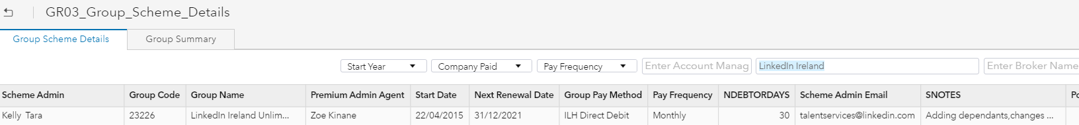

Added to file under tab ( Group scheme Details - GSD)

On the data tab

* In column O, Vlookup from column N on GSD tab- Scheme Admin Email addresses
* In column P, Vlookup from column L on GSD tab - Pay frequency
* In Column AC, Vlookup from column K on GSD tab - Group pay method
* In column AD, Vlookup from column J on GSD tab - Next renewal
* In column AE, deduct 12 months from column AD to get previous renewal date.
* In column AF,next Payment due – Invoices should generate on the same day each month/qtr/yearly. Take the previous renewal date (column AE) and add in the number of months from last renewal to current date to get the current period,
* In column AH, add ate is AF to the credit terms in AG to get the payment due date. –

Eg - TikTok 3416275 – Last renewal is 1/2/2021

It’s a monthly pay frequency so last invoice sent was 1/5/2021

Add the number of credit days which is 30 to the date the last invoice was generated

Payment due date is 31/5/2021

* Insert a column still to pay
* Insert a column First Reminder – Create a sum to add 5 days onto payment due date
* Insert a column Second Reminder – Create a sum to add 15 days onto payment due date
* Insert a column Cancellation – Create a sum to add 35 days onto payment due date

**Step 5**

* In column still to pay
* Open Eft file –

BANKING 2021\PAYMENT PROCESSING\PAYMENT PROCESSING\EFT PAYMENTS\2021

* On the EFT file, filter by current month
* VLOOKUP from columns H (Payer ID) and Column I (Group Name) on the EFT file and compare to column C (Group Code) and column D (Group Name) on the aged debt file.
* If match appears – Mark as YES
* If match doesn’t appear – Mark as NO
* If Yes, no action required as payment was received
* If No action is required

If no send the 1st Reminder

* Automatic generic 1st reminder email scheduled to be sent 5 days after payment due

Follow above steps and if payment still not received send 2nd reminder

* Automatic generic 2nd reminder email schedules to be sent 15 days after payment due

Follow above steps and if payment still not received send cancellation notice

* Cancellation notification sent 30/35 days after payment due

Confirm time periods